React.js Component Creation

name: Mandati Dharani

email: dharanimandati@gmail.com

Roll NO: 20NN1A0523.

College Name: Vignan’s Nirula Institute of Technology and Science For women

University: JNTUK

source code:

CARD COMPONENT:

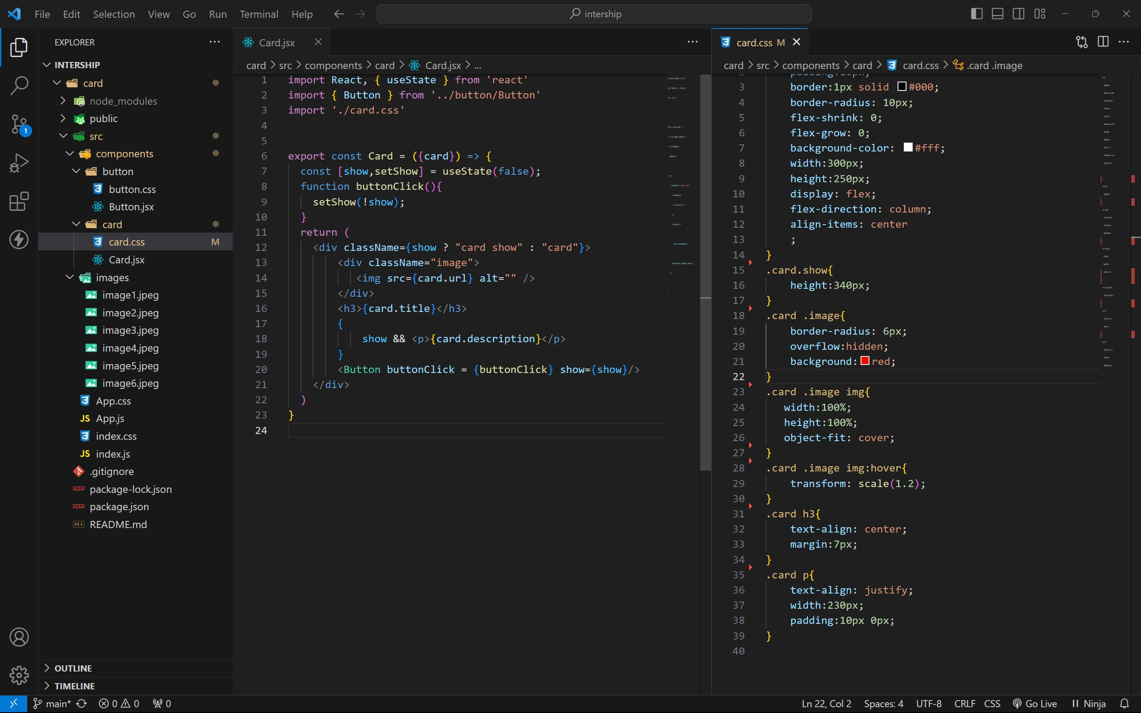

BUTTON COMPONENT:

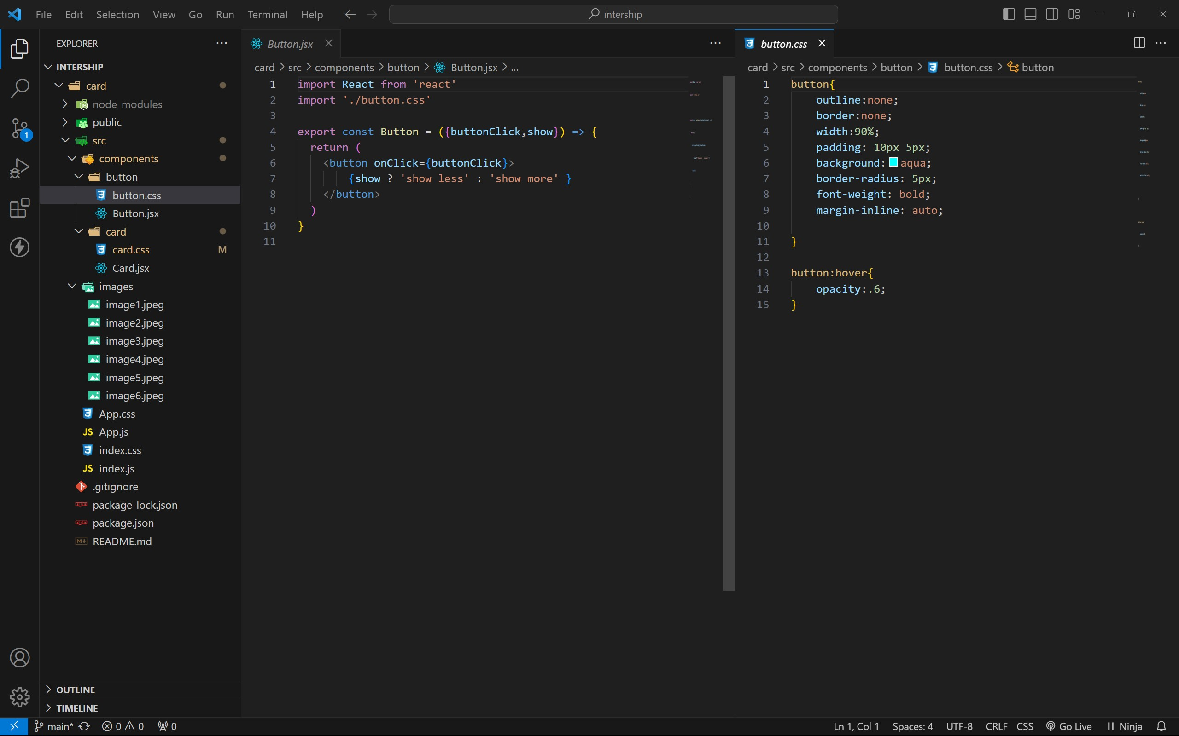

APP COMPONENT:

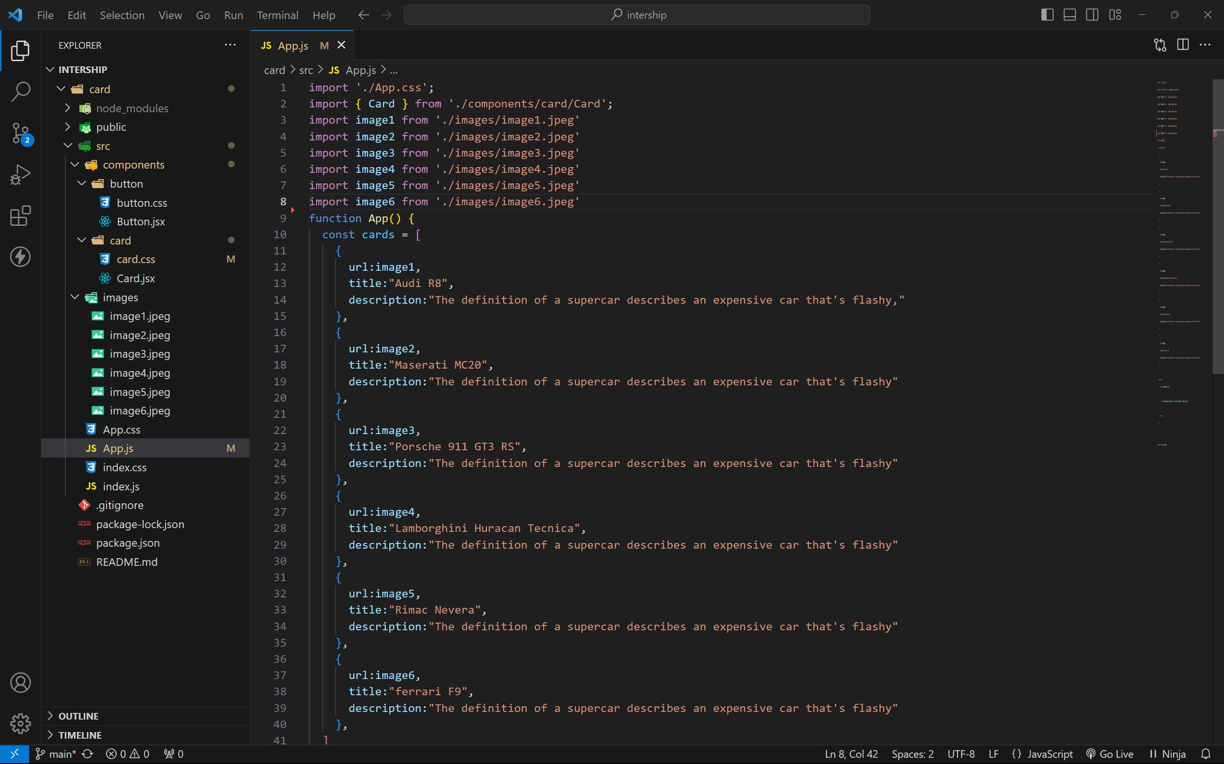

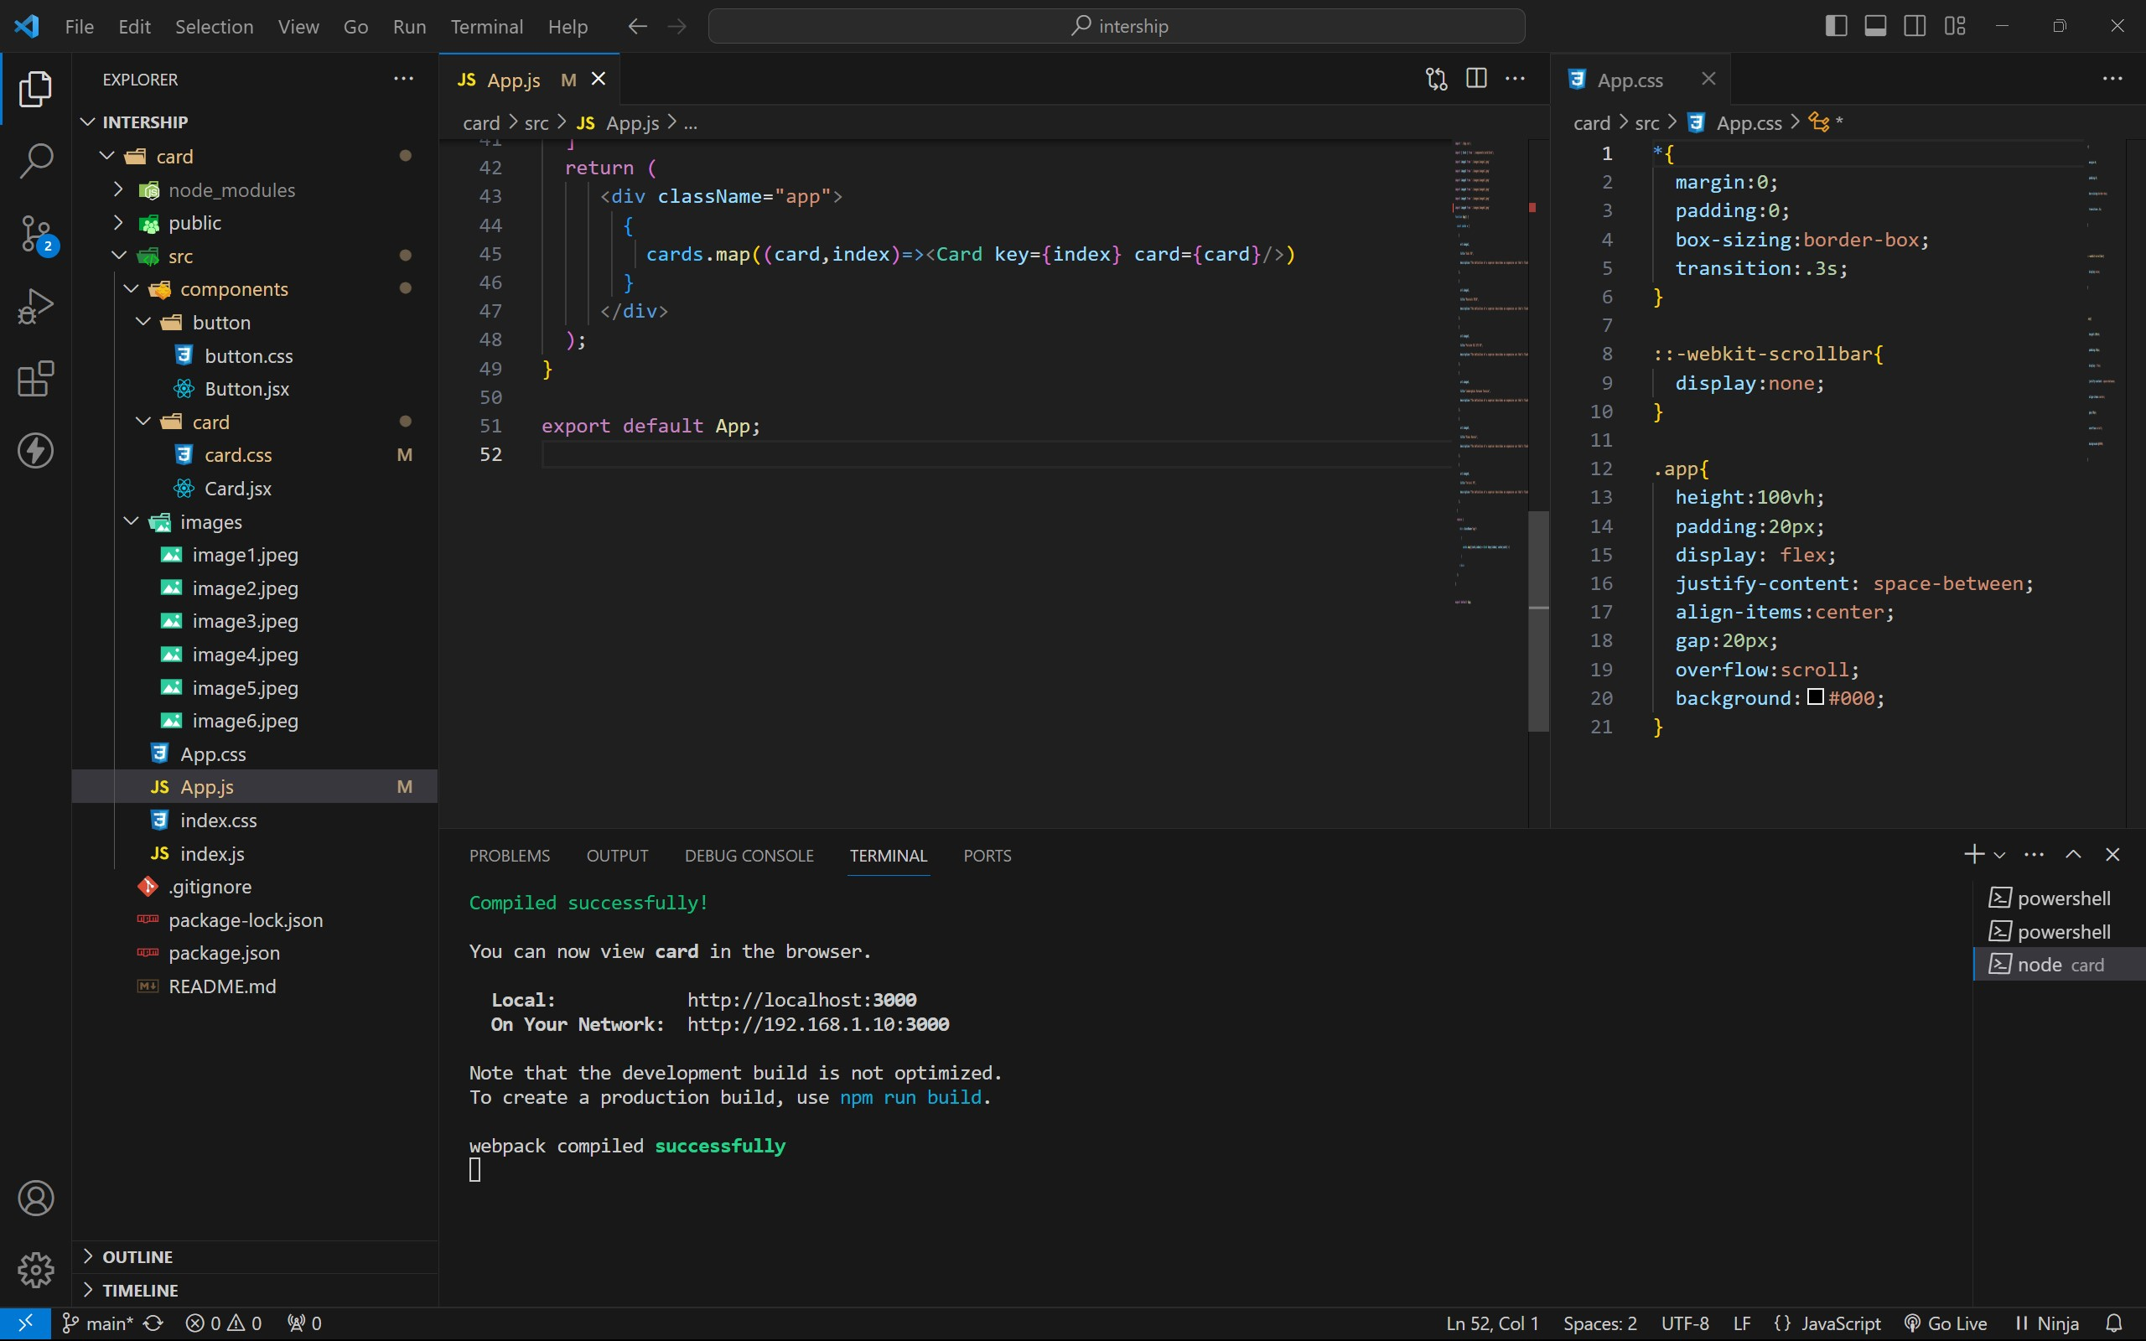

approach:

1. initially taking an array of objects like below

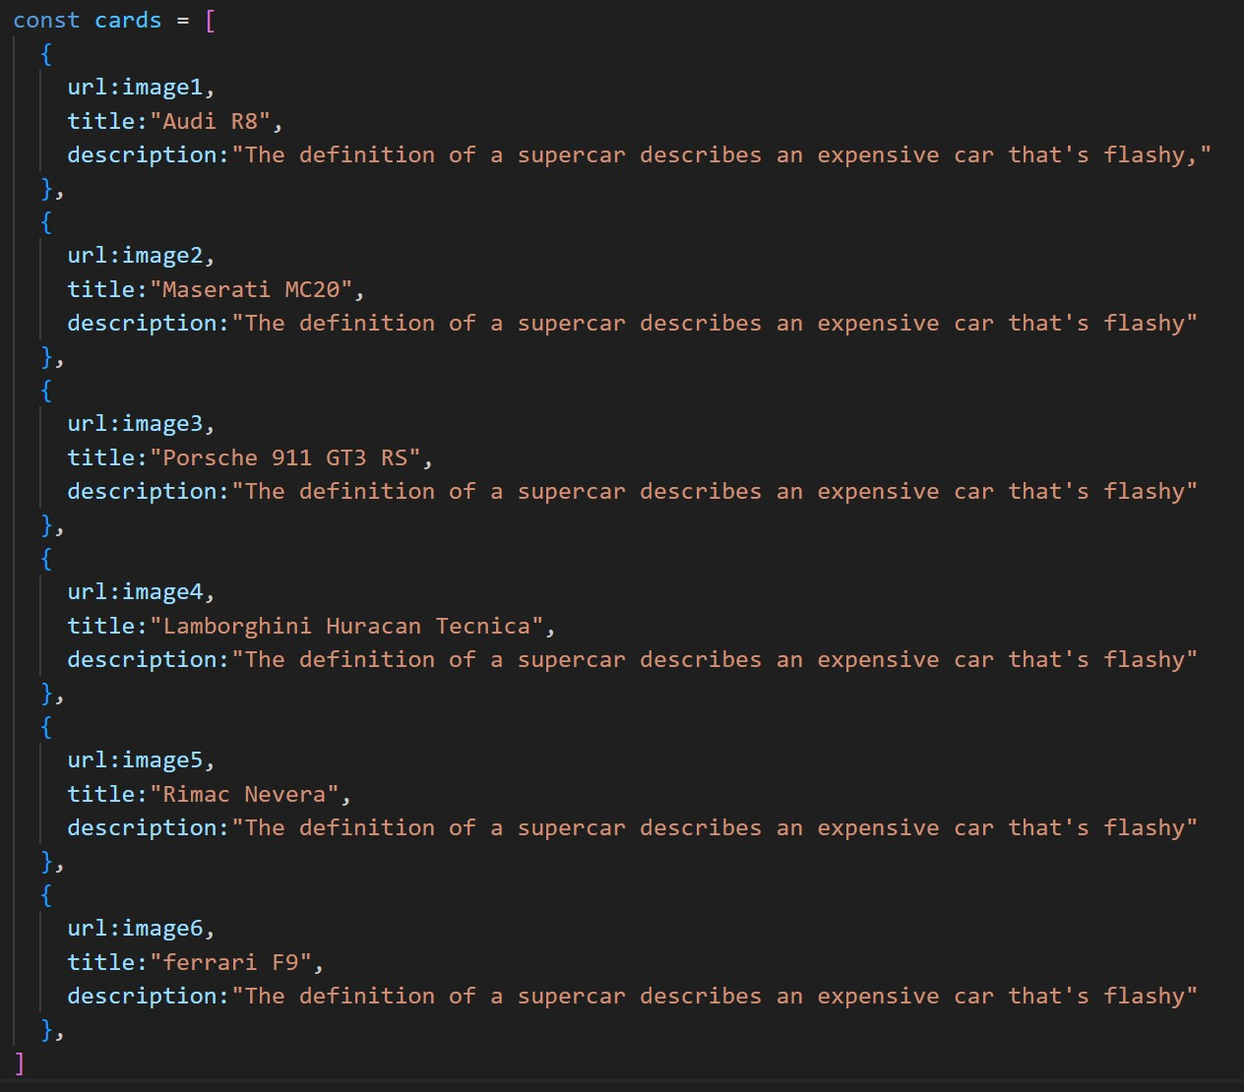

1. . Passing this card array to child (card component) of App component by using props.
2. . getting data as argument like {card} in card component.
3. . in card component i use one state [show, set Show] to get extra info as

description.

1. . When we click the button then show becomes true by assigning set Show (! show).

OUTPUT:

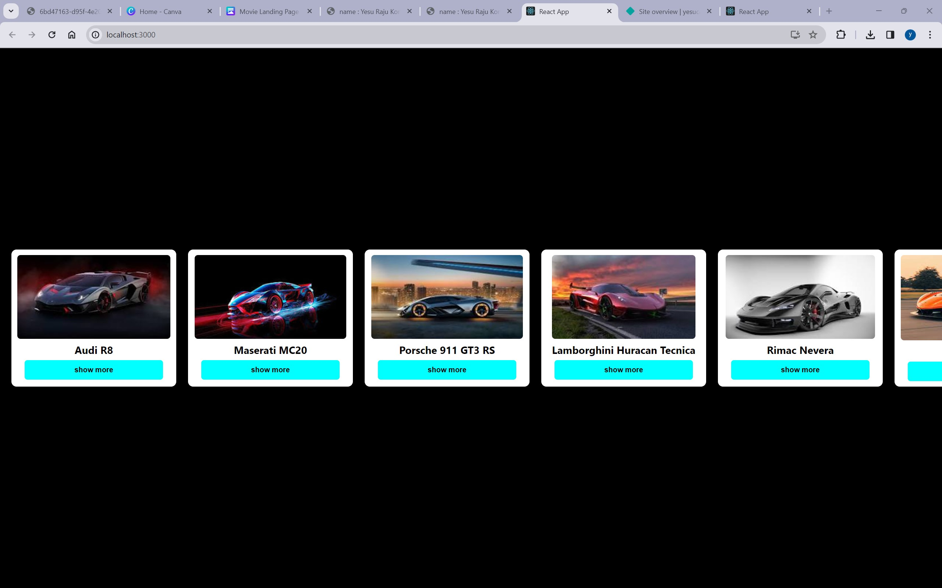

AFTER BUTTON CLICKS :

